Module–1

1. What is SDLC

SDLC is a stands for Softwere Devlopment life cycle. SDLC is the cost-effectiv and time -efficient process that development teams use to design and build high-quality software.

1. is software testing? What

Softwer testing isb a prosses to identify the correctness,completeness,and quality of developed computer software.

1. What is agile methodology?

Agile model is a combination of iterative and incremental process models with focus on process adaptability and customer satisfaction by rapid delivery of working software product.

1. What is SRS

SRS is Stends for SoftwareRequirement Specification. SRS is is a complete description of the behavior of the system to be developed.

1. What is oops

Opps is object oriented programming system.

1. Write Basic Concepts of oops

In OOPS we have 6 Concepts

Object

Class

Encapsulation

Inheritance

Polymorphism

Abstraction

1. What is object

Object is a instance of class

1. What is class

class is a collection of data member and member function testing with its behavior Object is a instance of class

1. What is encapsulation?

In Encapsulation it is use for data hiding. It Wrapping up of data in to single unit.

1. What is inheritance?

In inheritance a properties of parent class extends in to child class .

1. What is polymorphism?

Polymorphism has Ability to tack one name having multiple forms.

1. Draw Usecase on Online book shopping.

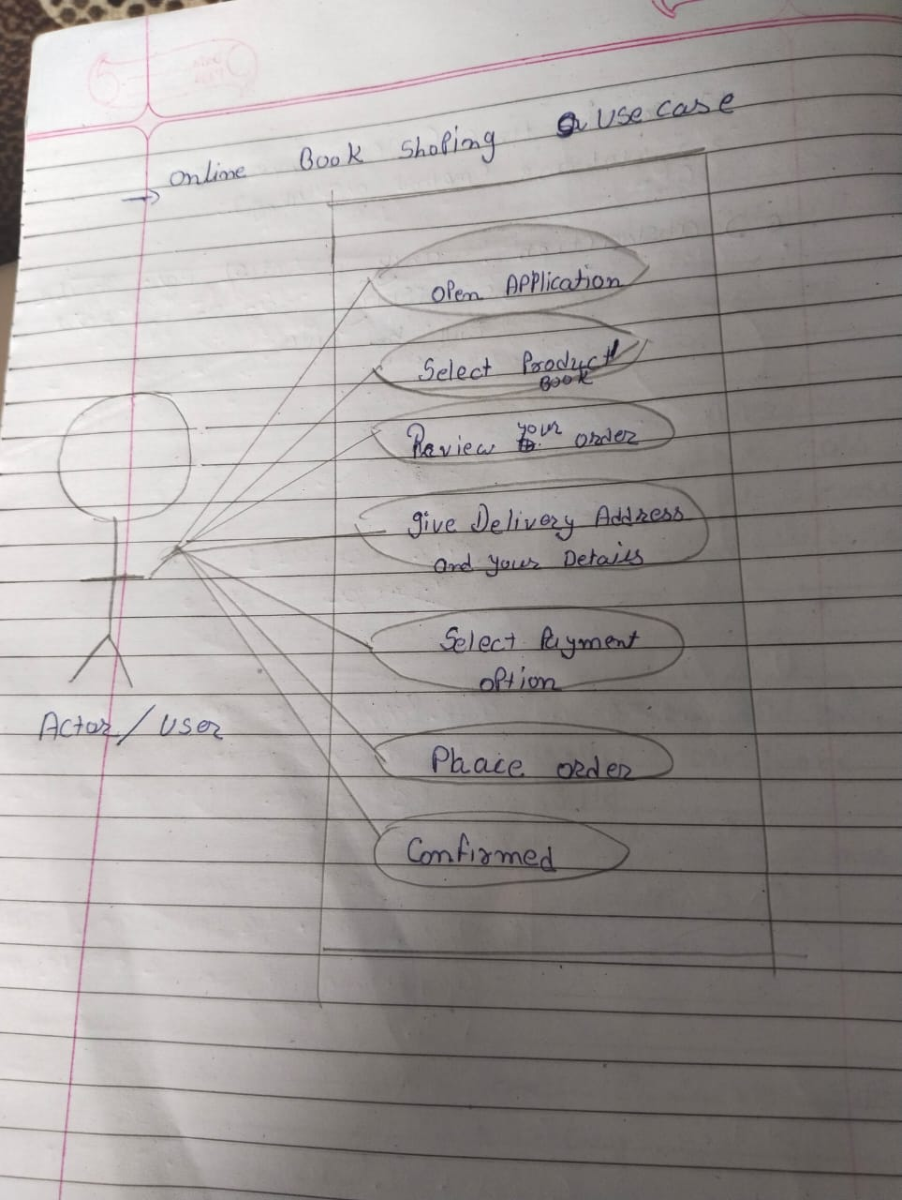

1. Draw Usecase on online bill payment system (paytm)

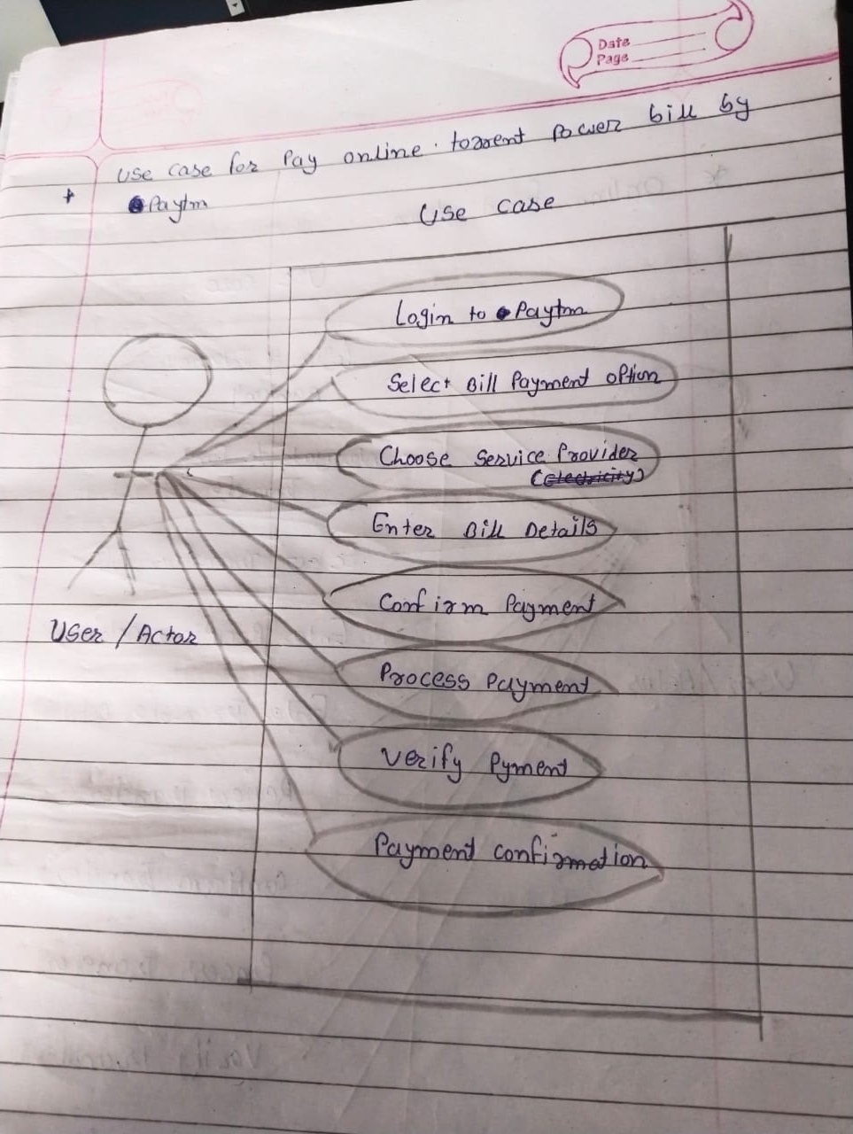

1. Write SDLC phases with basic introduction

SDLC is a stands for Softwere Devlopment life cycle. SDLC is the cost-effectiv and time -efficient process that development teams use to design and build high-quality software.

* SDLC phases

RequirementGathering

Analysis Phase

Design Phase

Implementation Phase

TestingPhase

1. Explain Phases of the waterfall model

Pros

Simple and easy to understand and use.

Easy to manage due to the rigidity of the model.

Each phase has specific deliverables and a review process.

Phases are processed and completed one at a time.

Cons

No working software is produced until late during the life cycle.

High amounts of risk and uncertainty.

Not a good model for complex and object-oriented projects

1. Write phases of spiral model

Pros

• Changing requirements can be accommodated.

• Allows for extensive use of prototypes

• Requirements can be captured more accurately

Cons

• Management is more complex.

• End of project may not be known early.

• Not suitable for small or low risk projects and could be expensive for small projects.

1. Write agile manifesto principles
2. Explain working methodology of agile model and also write pros and cons.

methodology

• Agile SDLC model is a combination of iterative and incremental process models with focus on process adaptability and customer satisfaction by rapid delivery of working software product.

• Agile Methods break the product into small incremental builds.

• These builds are provided in iterations.

Pros

• Is a very realistic approach to software development

• Promotesteamwork and crosstraining?

• Functionality can be developed rapidly and demonstrated.

• Resource requirements are minimum

Cons

• Not suitable for handling complex dependencies.

• More risk of sustainability, maintainability and extensibility.

• An overall plan, an agile leader and agile PM practice is a must without which it will not work.

1. Draw usecase on Online shopping product using COD

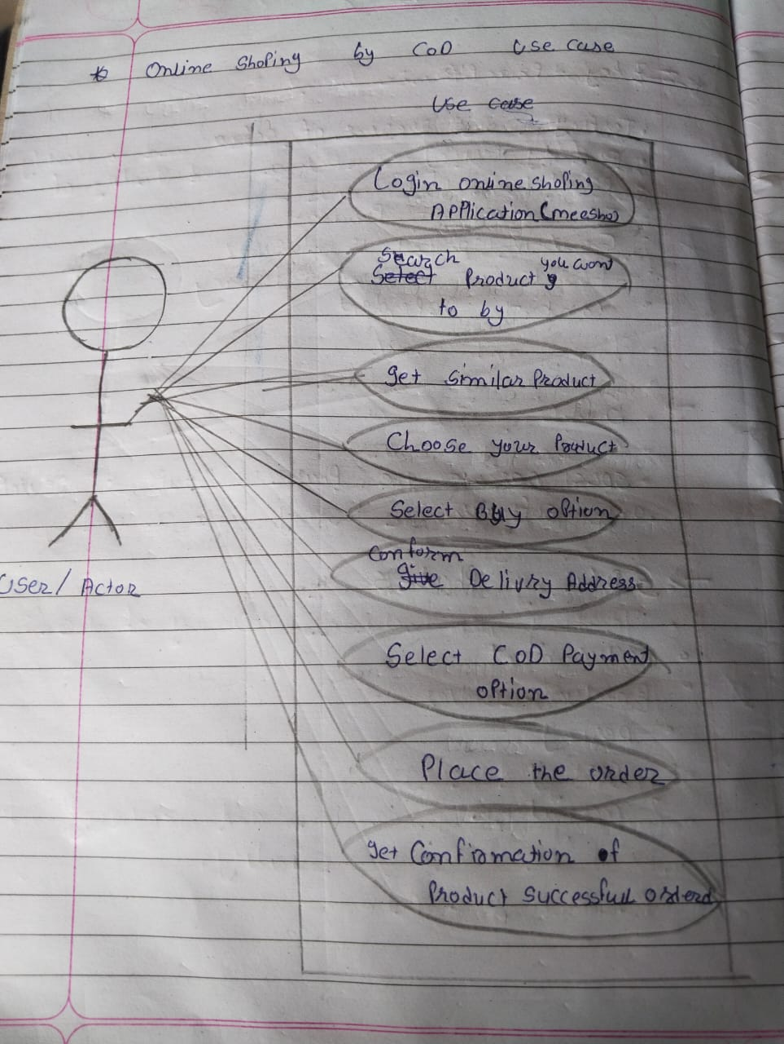

20)Draw usecase on Online shopping product using payment gateway.

